**OUTPUTS**

**Developing a Backend Admin for Learner’s Academy.**

**Flow chart:-**

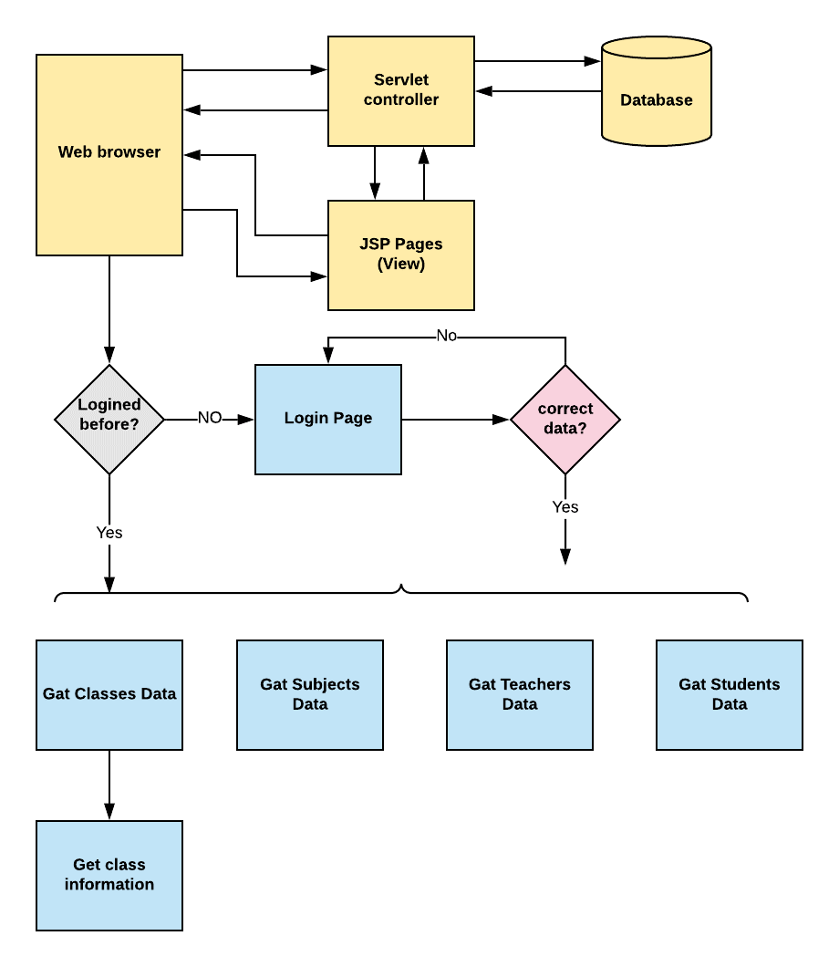

**1.Login Page:-**

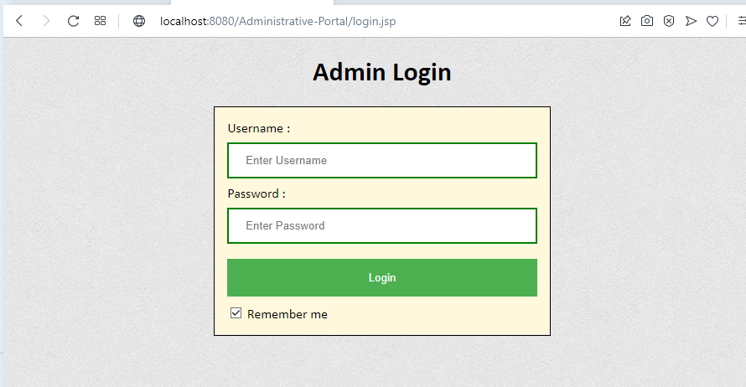

**2. Enter the Username and Password :-**

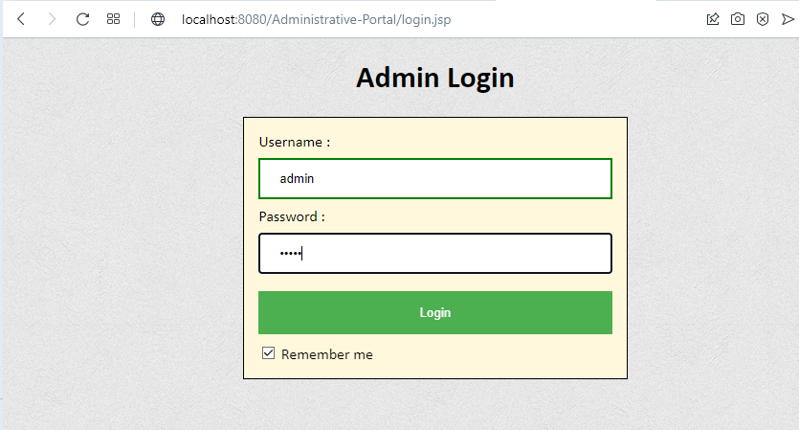

**3.Classes:-**

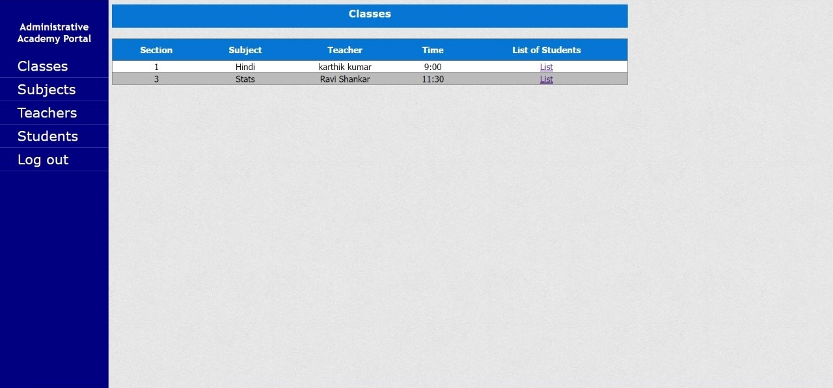

**3.1. List of students in Hindi classes section1:**

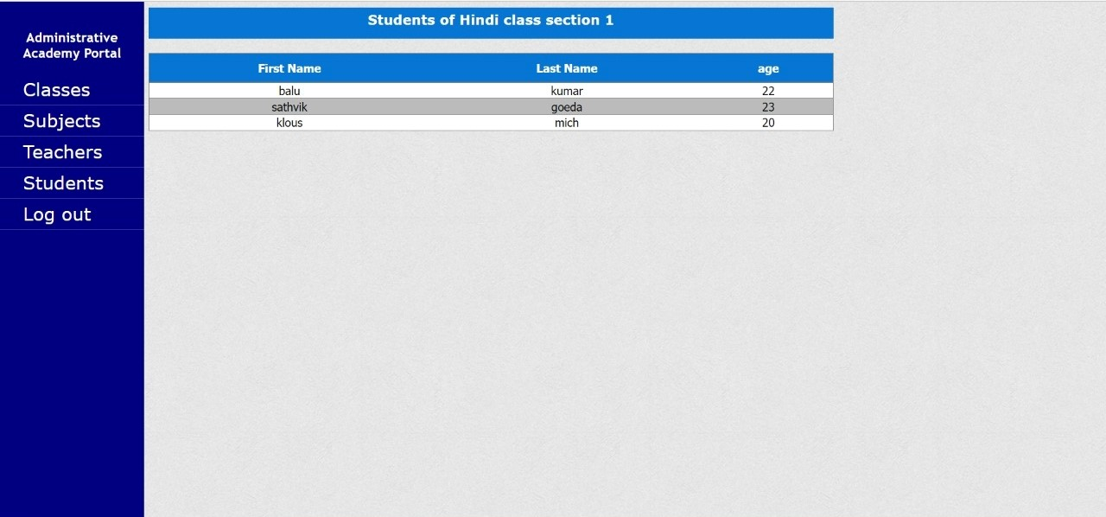

**3.2. List of students in Stats classes section3:**

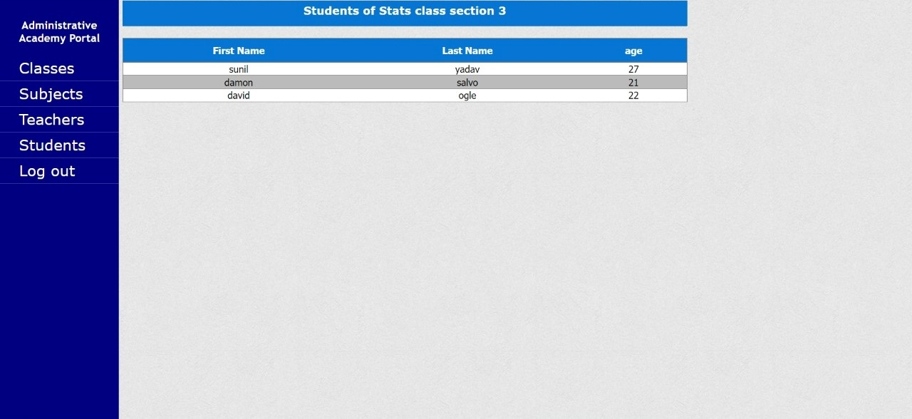

**4. Displaying Subjects:**

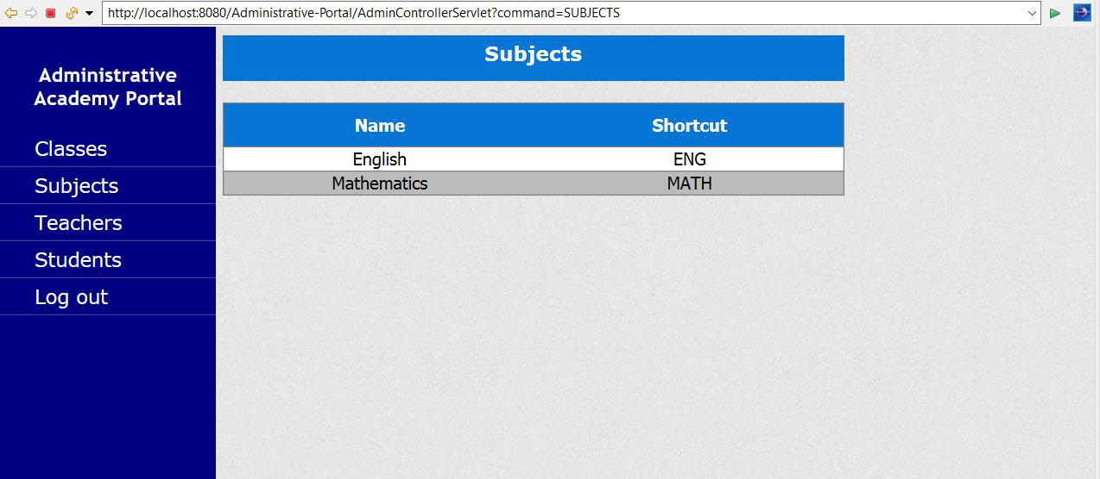

**5.Displaying Teachers:**

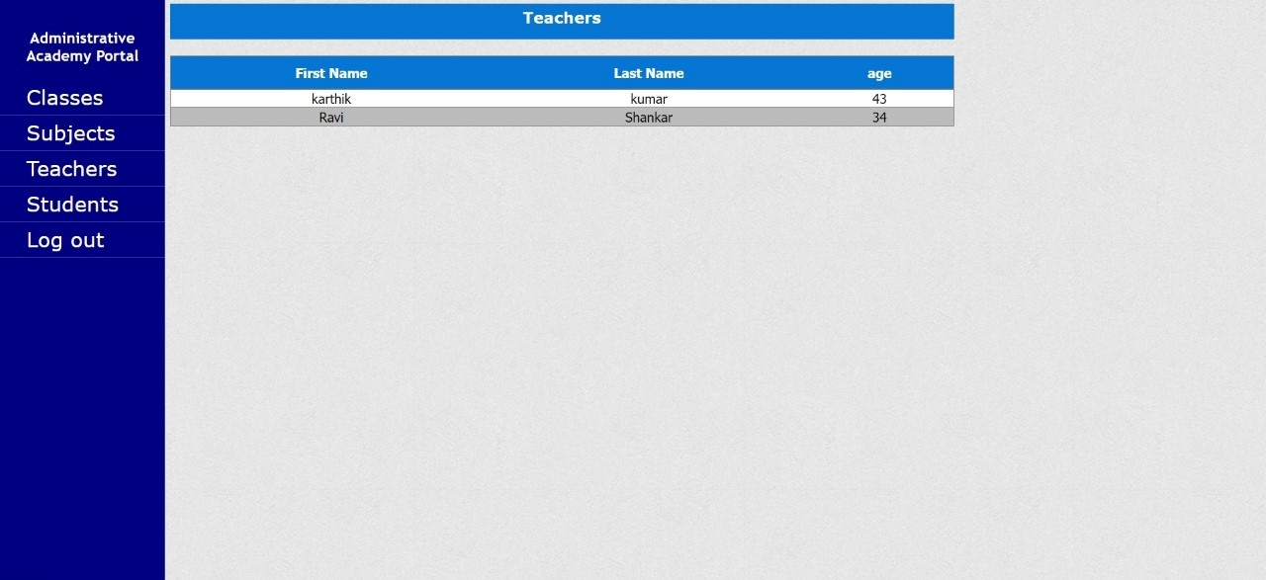

**6.Displaying Students:**

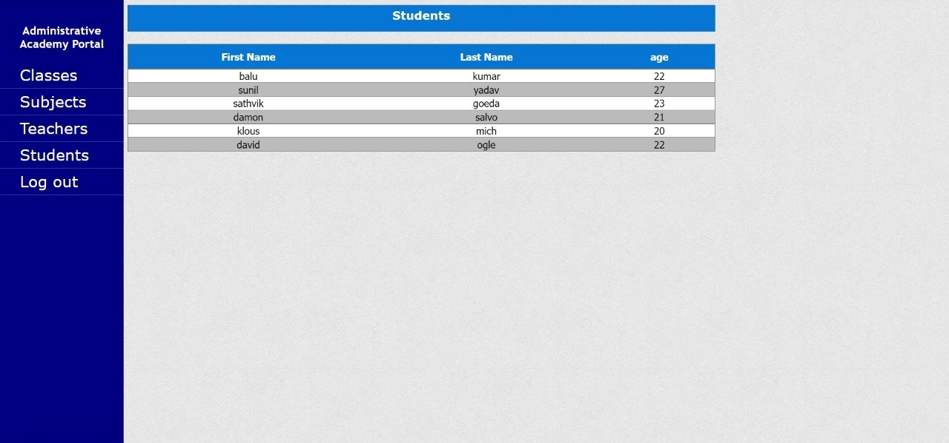

**7. Logout page:**

